MANA's December 2019 CRNA of Distinction
Rozanna Penney
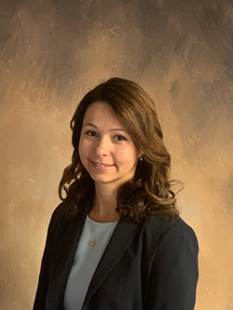Rozanna became a CRNA in 2009 after obtaining a Master’s in Science of Nurse Anesthesia (MSNA) from St. Joseph’s Hospital School of Anesthesia for Nurses and the University of New England. Prior to becoming a CRNA, she worked as an ED and ICU RN for five years.
Rozanna is known as both a talented clinician and inspiring leader. In 2016, she assumed the role of Chief Nurse Anesthetist at Heywood Hospital in a new anesthesia group which, at the time, was introducing the hospital to CRNAs for the first time ever. In helping establish this new group, Rozanna not only ensured that its CRNAs would be able to practice to the full scope of their licenses, but she also played an instrumental role in making CRNAs become eligible for “active member” status on the hospital’s medical staff. In addition to her ongoing role as Chief CRNA, her tenure at Heywood is notable for her initial appointment and subsequent promotions to various leadership positions on the hospital’s management team. She has served as Associate Director of Perioperative Services, then Director of Perioperative Services and, most recently, she was appointed to serve as a member of the hospital’s senior leadership team in the roles of Heywood Healthcare’s Vice President of Perioperative Services and Chief Advanced Practice Provider (APP) Officer.
Rozanna is quick to note that her success has been possible because she works with and leads a phenomenal team of people. She is surrounded by talented and supportive surgeons, anesthesiologists and APPs, compassionate and caring nurses, techs and staff and she is a member of a visionary senior leadership team. Lastly, Rozanna feels very strongly that each and every one of the CRNAs on her team are “CRNAs of Distinction”, including Christopher Barnes, CRNA, Anthony Craig, CRNA, Sarah Lamoreaux, CRNA, Alison Willnow, CRNA and Heather Archambeault, CRNA. She is deeply grateful for their support as well as their skills and professionalism which make each and every one of us proud to be a CRNA.

